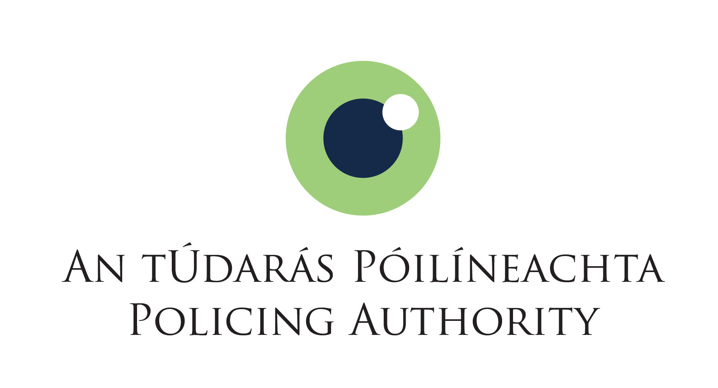

Open Competition for Executive Officer

APPLICATION FORM
Name

Contact Email Address

Contact Phone Number

Please specify if you require any special facilities or other reasonable accommodations for any aspect of the selection process e.g. wheelchair access, sign interpreter etc.
(Please note: You will be contacted in the course of the competition using the above contact details.)

EDUCATIONAL QUALIFICATIONS. Please give details of your most relevant qualifications, and please ensure you include the result.
Dates Attended  From To |  | School/College/Institute Attended | Course Pursued/Qualification Awarded | Result

SUMMARY DESCRIPTION OF CURRENT ROLE

Describe main duties and responsibilities

PREVIOUS RELEVANT EMPLOYMENT DETAILS

Name of Dept. / Organisation | Title of Post held | Brief Description of Duties | From  Month/ Year | To  Month/ Year

Key Competencies Form
Please outline an example of a specific achievement or contribution you have made during your career to date which clearly demonstrates your suitability for the level of Executive Officer in each of the competencies outlined below. Please do not exceed the 400 word limit for each answer.

People Management – max. 400 words
Provide a brief example of how you have developed good working relationships with others and how you have made a contribution as part of a team.
- Consults and encourages the full engagement of the team, encouraging open and constructive discussions around work issues
- Gets the best out of individuals and the team, encouraging good performance and addressing any performance issues that may arise
- Values and supports the development of others and the team
- Encourages and supports new and more effective ways of working
- Deals with tensions within the team in a constructive fashion
- Encourages, listens to and acts on feedback from the team to make improvements Actively shares information, knowledge and expertise to help the team to meet its objectives

Analysis Decision Making – max. 400 words
Describe a time when you had to analysis a large amount of information or data and make decisions or recommendations on the results.
- Effectively deals with a wide range of information sources, investigating all relevant issues
- Understands the practical implication of information in relation to the broader context in which s/he works – procedures, divisional objectives etc
- Identifies and understands key issues and trends
- Correctly extracts & interprets numerical information, conducting accurate numerical calculations
- Draws accurate conclusions & makes balanced and fair recommendations backed up with evidence.

Delivery of Results – max. 400 words
Provide an example of how you have demonstrated the planning and organisational skills necessary to be successful for this role, in particular where you may have had to manage multiple projects or deadlines.
- Takes ownership of tasks and is determined to see them through to a satisfactory conclusion
- Is logical and pragmatic in approach, setting objectives and delivering the best possible results with the resources available through effective prioritisation
- Constructively challenges existing approaches to improve efficient customer service delivery
- Accurately estimates time parameters for project, making contingencies to overcome obstacles
- Minimises errors, reviewing learning and ensuring remedies are in place
- Maximises the input of own team in ensuring effective delivery of results
- Ensures proper service delivery procedures/protocols/reviews are in place and implemented

Interpersonal & Communication Skills – max. 400 words
Provide an outline of how you meet the verbal and written communication requirements for this role (experience in writing reports, taking minutes, preparing presentations or meeting packs or dealing with stakeholders).
- Modifies communication approach to suit the needs of a situation/ audience
- Actively listens to the views of others
- Liaises with other groups to gain co-operation.
- Negotiates, where necessary, in order to reach a satisfactory outcome
- Maintains a focus on dealing with customers in an effective, efficient and respectful manner
- Is assertive and professional when dealing with challenging issues
- Expresses self in a clear and articulate manner when speaking and in writing

Drive and Commitment to Public Service Values – max. 400 words
Give a brief description of a how you feel you have demonstrated the necessary qualities for this role.
- Is committed to the role, consistently striving to perform at a high level
- Demonstrates flexibility and openness to change
- Is resilient and perseveres to obtain objectives despite obstacles or setbacks
- Ensures that customer service is at the heart of own/team work
- Is personally honest and trustworthy
- Acts with integrity and encourages this in others

Specialist Knowledge, Expertise and Self-Development – max. 400 words
Briefly outline how you have developed and met the knowledge and experience requirements for this role having regard to the key responsibilities of the role as set out in the office notice.
- Displays high levels of skills/ expertise in own area and provides guidance to colleagues
- Has a clear understanding of the role, objectives and targets and how they support the service delivered by the unit and Department and can communicate this to the team
- Leads by example, demonstrating the importance of development by setting time aside for development initiatives for self and the team

